

**COMSATS University Islamabad, Vehari Campus**

**Lab Mid**

***Submitted By***

**Mavra Bibi CIIT/SP22-BSE-028**

***Submitted to***

**Mam Yasmeen Janah**

***Bachelor of Science in Computer Science (2022-2026)***

**Question no1:**

**You have been hired as a Full Stack Developer. Your task is todevelop a complete web application that allows users to view alist of available books, search for books by author, and add newbooks to the system. You are required to build both the frontendand the backend components of this application**.**On the frontend, design a responsive interface using HTML,**

**CSS (Bootstrap), and JavaScript. The main page should displayall books retrieved from the backend via a REST API. A searchbar must allow users to filter books based on the author name**

**[CLO5][25]only. Additionally, create a separate page with a form to add newbooks by entering the book’s title, author, and price. This formshould send the data to the backend using JavaScript’s fetch()API.On the backend, use Node.js with Express to build a RESTful**

**API connected to a MongoDB database. The API should supportthe following operations: retrieve all books, search books byauthor, and add new books. Implement appropriate routing andensure the use of environment variables for configuration. Use MongoDB (with either the native driver or Mongoose) to handleall data storage.Your project should be well-organized with separate folders forfrontend and backend, follow best practices for modular**

**coding, and demonstrate full interaction between the frontendand backend through API requests.**

**Answer:**

**Backend(Models->Book.js):**

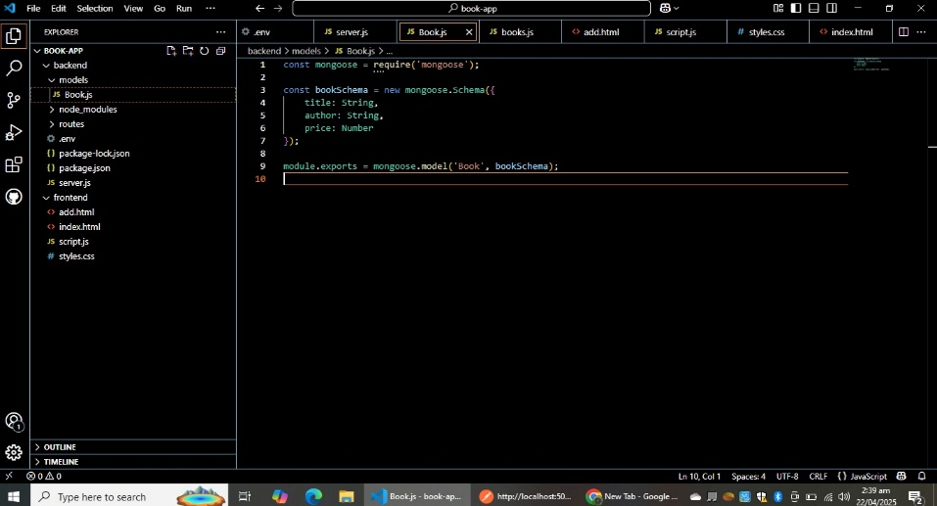

**Backend(routes->book.js):**

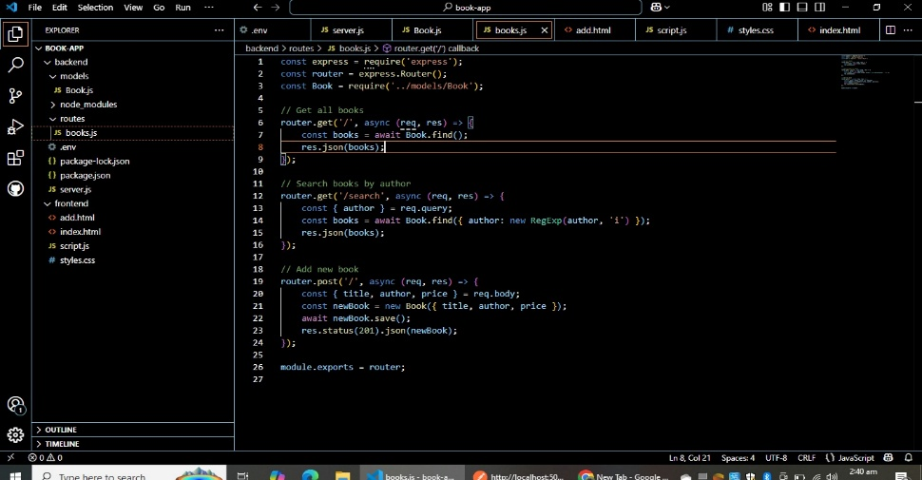

**.env:**

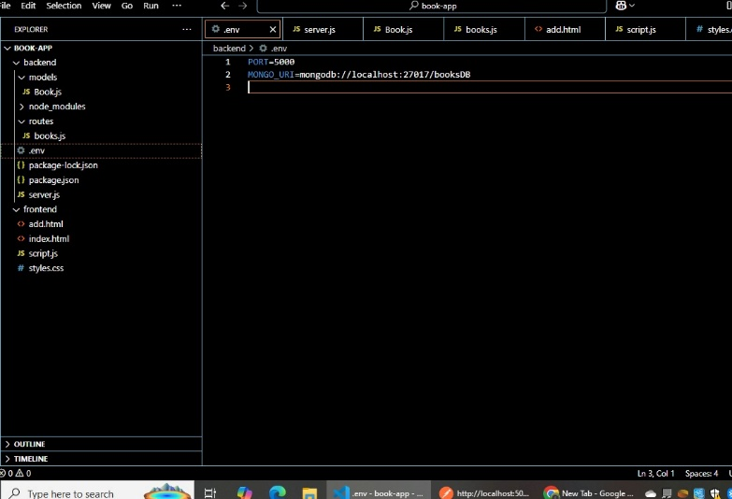

**Frontend(add.html):**

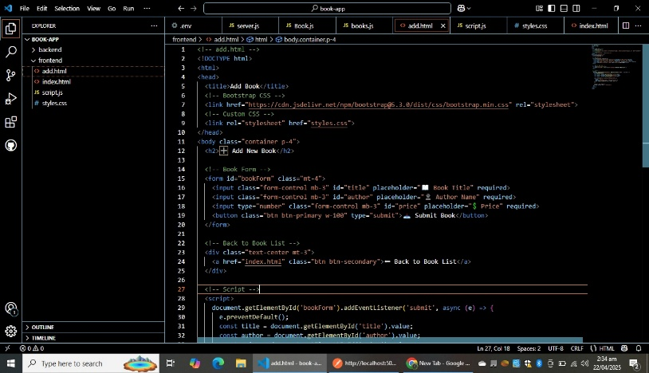

**Frontend(Index.html):**

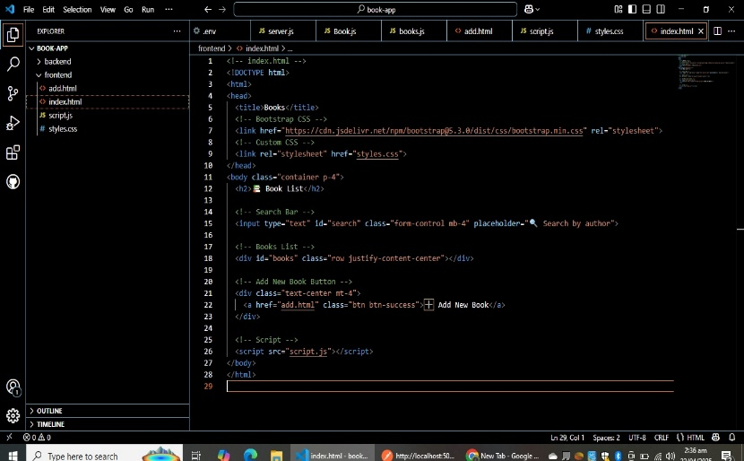

**Frontend(script.js):**

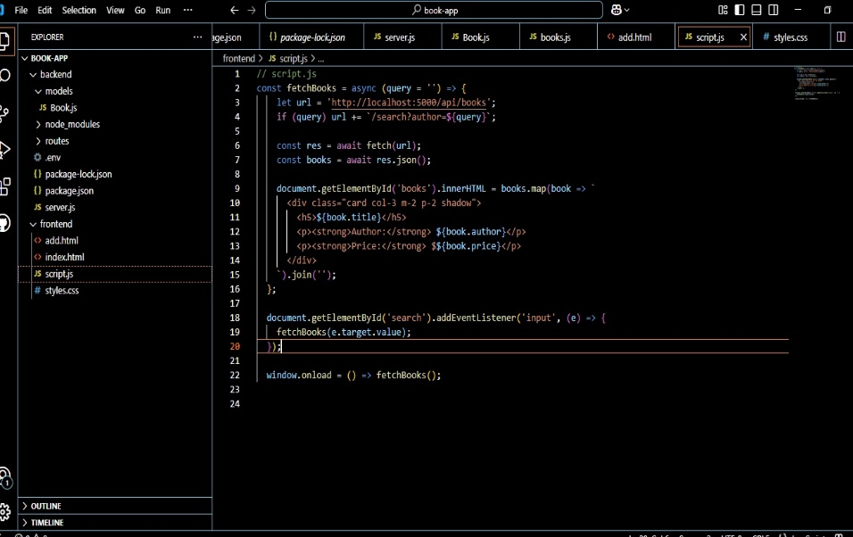

**Style.css1:**

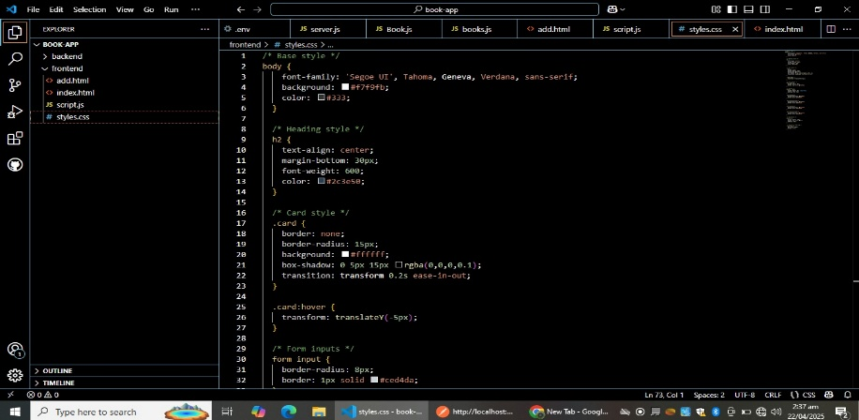

**Style.css2:**

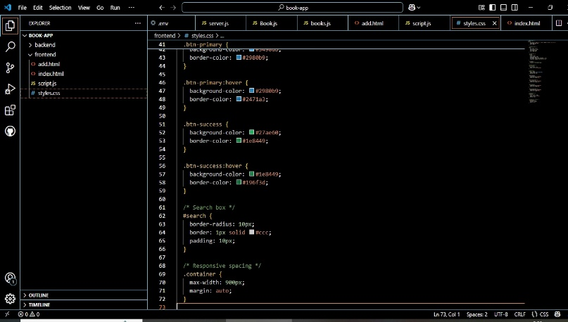

**Backend connected:**

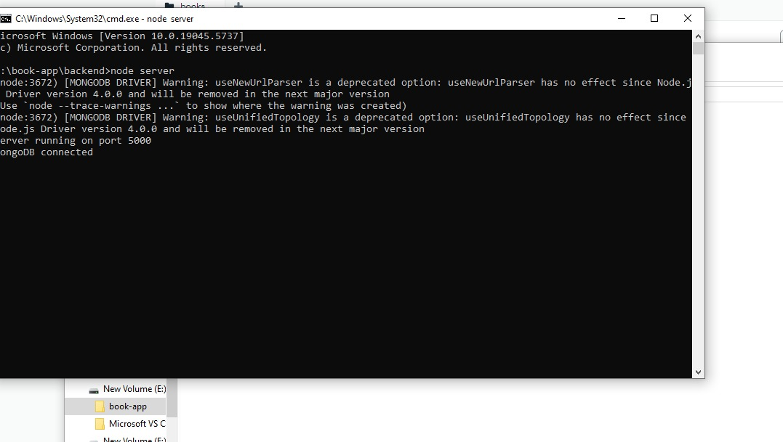

**Postman(post):**

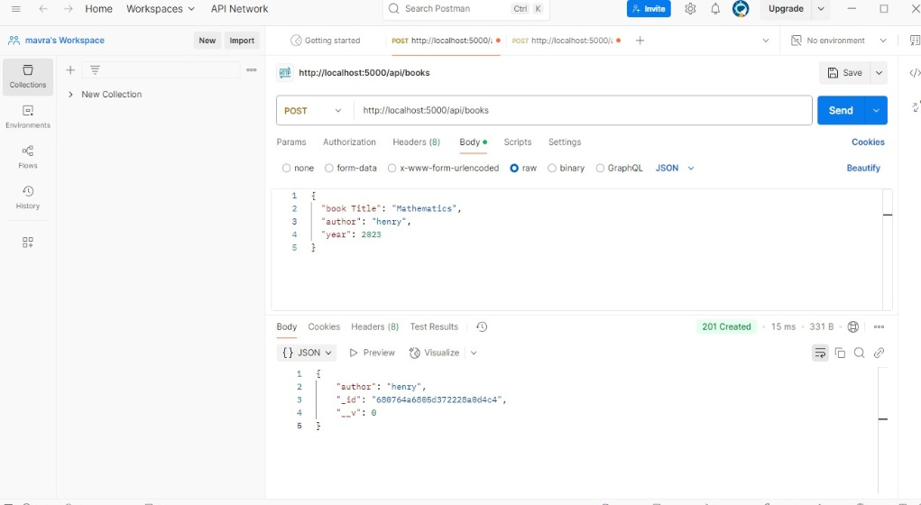

**Postman(get):**

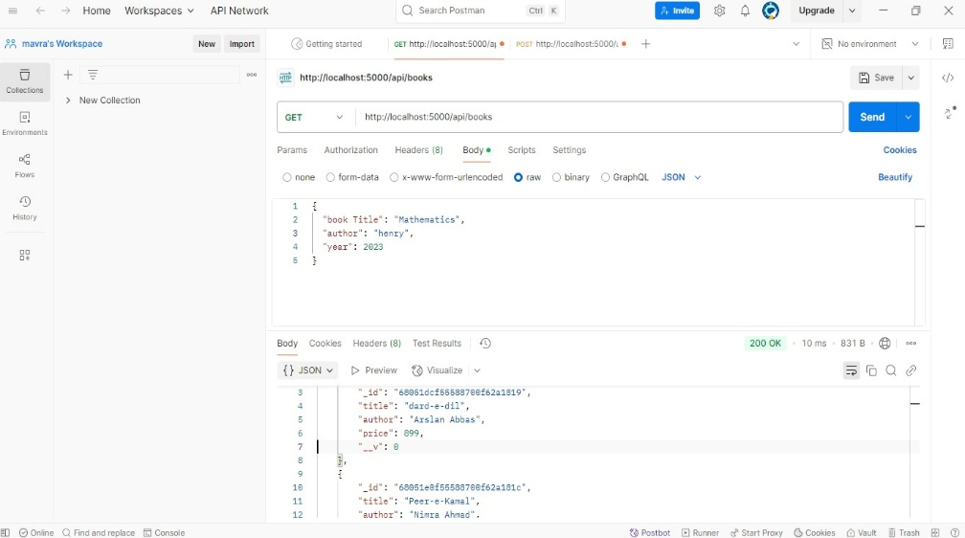

**MongoDBCompass:**

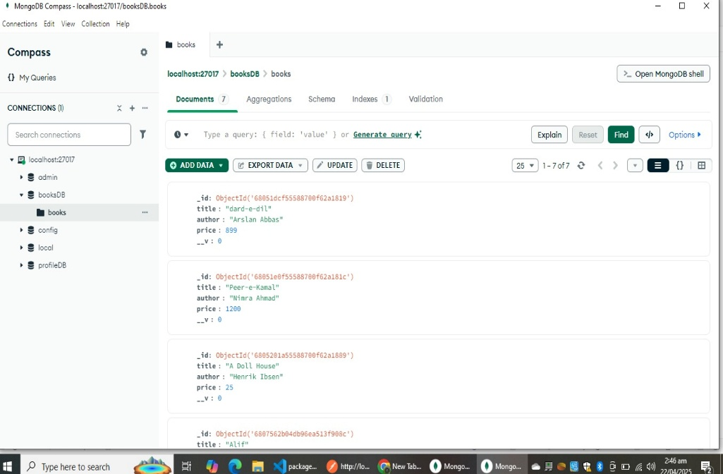

**OUTPUT:**

**Add Book**

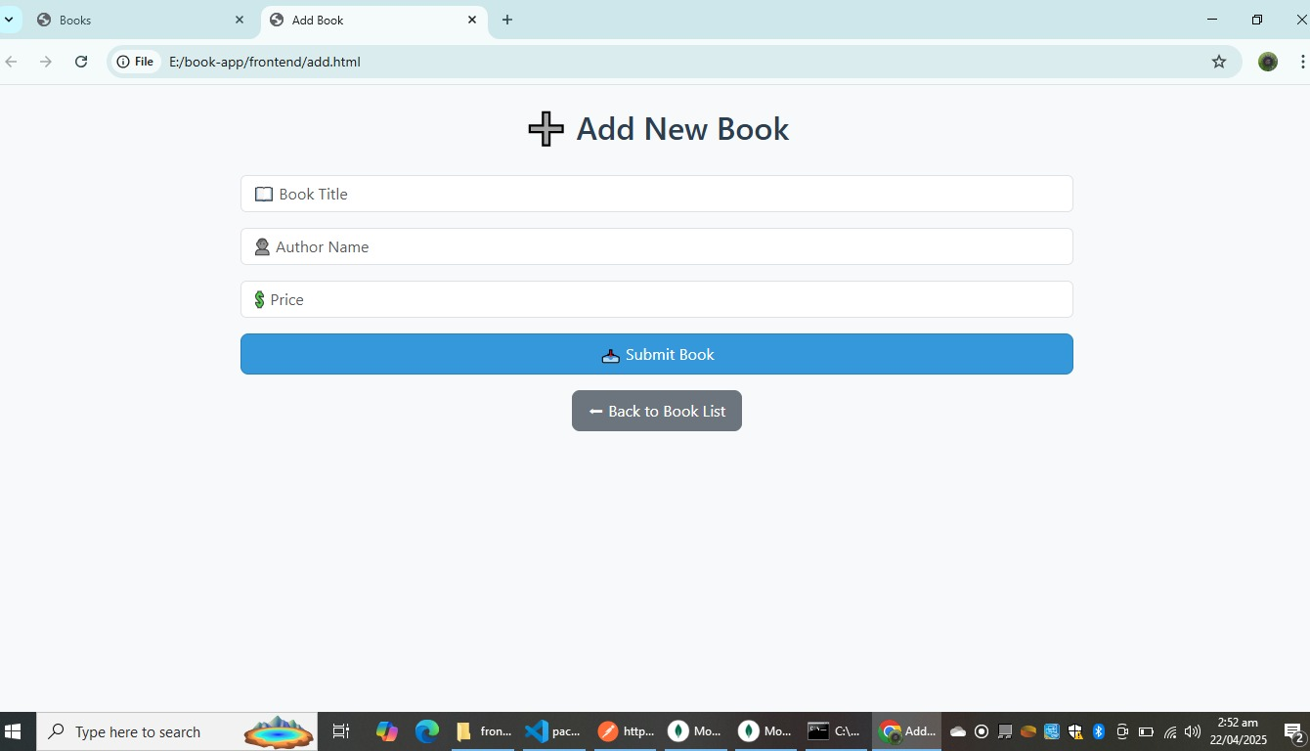

**LIST Book:**

